**RECIEVER SIDE**

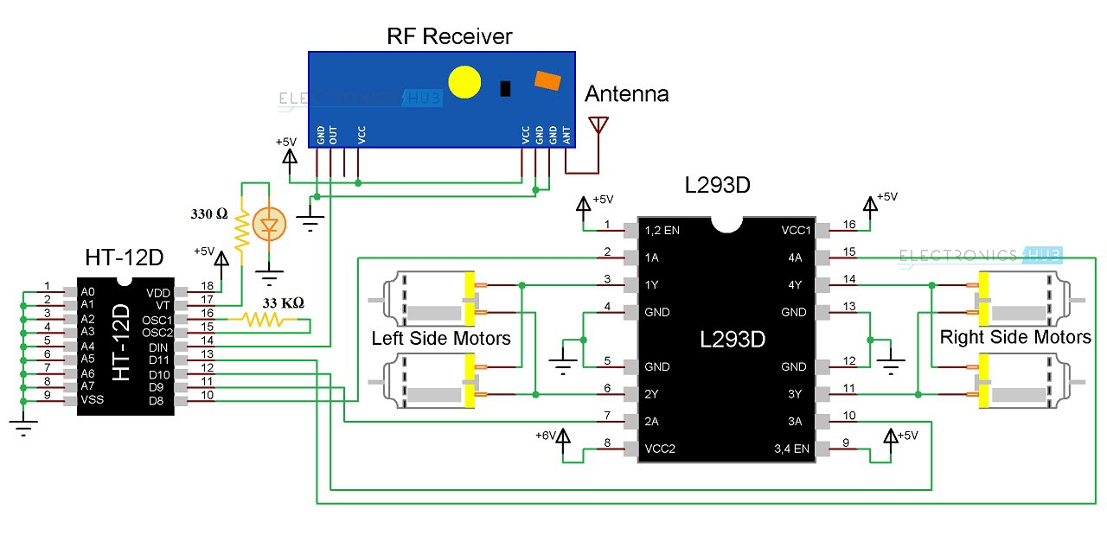

**Components for Receiver Section**

* L293D Motor Driver IC
* HT-12D Decoder IC
* 434 MHz RF Receiver
* 33KΩ Resistor
* 330Ω Resistor
* LED
* 4 Geared Motors with Wheels
* Robot Chassis

### **Circuit Design of Hand Gesture Controlled Robot**

#### Receiver Section

The receiver section of the robot consists of an RF Receiver, HT-12D Decoder IC, L293D Motor Driver IC and a robot chassis with four motors connected to wheels.

HT-12D is the decoder IC that is often associated with RF Receiver. It converts the serial data received by the RF link into parallel data. A0 to A7 (Pin 1 to Pin 8) are the address pins and must be matched with the address pins of the encoder.

Since the address pins of encoder (HT-12E) are grounded, the address pins of decoder must also be grounded. Hence, pins 1 to 9 (A0 – A7 and Vss) are connected to ground. The serial data from the RF Receiver is given to Din (Pin 14) of the decoder IC.

HT-12D has an internal oscillator and an external resistor of 33KΩ is connected between OSC1 and OSC2 (Pins 16 and 15). Pin 17 (VT) indicates a valid transmission of data and this pin will be high when a valid data is present on the data pins. An LED in series with a 330Ω resistor is connected to this pin to indicate a valid data transmission.

Pins 10 to 13 (D8, D9, D10 and D11) of HT-12D are the parallel data out pins. They are connected to the input pins of the L293D motor driver IC (Pins 2, 7, 10 and 15 respectively).

L293D motor driver IC is used to provide the necessary current (for both forward and reverse directions) to the motors. Pins 1 and 9 are the enable pins and are connected to VCC (+5v) along with Pin 16 (which is the logic supply). Pins 3 – 6 and 11 – 14 are the outputs and are connected to the four motors.

Pin 8 is the Motor Supply Pin and is connected to a separate power supply. Hence, you will need two batteries in the Receiver Section; one for the Circuit and one for the motors.